Mrs. Nadeau’s 6th Grade Distance Learning Assignments
Week 3 : May 4th thru May 8th
Daily Work Expectation: 2-3 hours per day of schoolwork
Daily Office Hours:  M W F 9:00am to 11:00am T TH 2:00pm to 4:00pm  Contact Info: mailto:cnadeau@tusd.net  Text: 925-487-2068 (no phone calls please) |  | Zoom Class Meetings Wednesday @ 2:30  *Note the new day  (attendance not required)  Video Chat available in Microsoft Teams during my office hours for one on one or small group instruction as needed.
Materials and Resources | Required Links for Digital Option 🖳  🖳 Digits: http://mymathuniverse.com/  🖳 StudySync: https://connected.mcgraw-hill.com/  🖳 Office 365: https://login.microsoftonline.com/  Digital Work should be submitted for grading immediately. | Required Materials for Paper Option ✍  ✍ Math- Digits Student Companion  ✍ StudySync Reading and Writing Companion  ✍ Week 3 Packet contains Suggested Pacing Guide Math, “Roll of Thunder, Hear My Cry” Comprehension Quiz, Writing Prompt, Narrative Framework and Checklist  **Carefully tear out all completed companion pages, stack them with other completed print materials, and any work you have done on notebook paper, staple in the top left, and write your NAME and WEEK NUMBER in the top right.
Math  *Rates | 🖳 Digits: http://mymathuniverse.com/  - Lesson 11-4: Measurements and Ratios and 11-4 Homework  - Lesson 11-5: Choosing the Appropriate Rate and 11-5 Homework  - Lesson 11-6: Problem Solving and 11-6 Homework | ✍ Math Packet and Digits Student Companion  For each lesson, the Launch, Got Its, and Close and Check are in the Companion. Key Concepts, examples, additional practice, and homework are in the packet. Follow the sequence in your Math Packet for Week 3.  - Lesson 11-4: Measurements and Ratios and 11-4 Homework  - Lesson 11-5: Choosing the Appropriate Rate and 11-5 Homework  - Lesson 11-6: Problem Solving and 11-6 Homework
ELA  *Reading and Writing Narratives  *Dialogue | 🖳 StudySync: https://connected.mcgraw-hill.com/  - “Roll of Thunder, Hear My Cry” by Mildred D. Taylor Intro, Vocabulary, and First Read with Annotations (at least 5)  - "Roll of Thunder...” Comprehension Quiz  - "Roll of Thunder...” Close Read: Read a 2nd time  - Watch SyncTV Discussion of “Roll of Thunder...”  - "Roll of Thunder...”” Think Questions: Restate questions/ respond completely. Cite evidence where appropriate.  - Writing: Respond to the prompt completely and thoughtfully. Read your essay, revise and edit, before submitting your work for grading.  - Complete 2 Peer Reviews  - Planning your own narrative for Week 4 (emailed Framework and Checklist in Outlook) | ✍ StudySync Companion and Handout  - Read “Roll of Thunder, Hear My Cry” by Mildred D. Taylor: Intro pg. 255  - Vocabulary- Define these terms before reading: audible, imprisoned, mortgage, overshadow, and venture  - Complete First Read “Roll of Thunder...” pgs. 256-259 with annotations (at least 5)  - Reading Comprehension Quiz (packet)  - Respond to Think Questions pg. 259. Use lined notebook paper, restate questions, and write complete responses with evidence where appropriate.  - Writing Prompt (packet) Use lined notebook paper, revise and edit before submitting your work for grading.  - Planning your own narrative for Week 4 (Use Framework and Checklist)
History  *Complete Ancient Civ Project | 🖳Office 365 https://login.microsoftonline.com/ Typed in Word and Shared with Mrs. Nadeau Due by May 8th  Revised Version of the Ancient Civilization Research Report:  (See Week 1 Planner for Criteria) | ✍ Lined Notebook Paper, Ancient Civilization Notecards, Outline, or other resources: Due May 8th  Revised version of the Ancient Civilization Research Report:  (See Week 1 Planner for criteria)
Reading | Read 30 minutes (or more!) per day – use the ATTACHED LOG to record your reading!
The Cay One-Pager | Complete The Cay One-pager due May 8th  (Directions for this were given in class, but I will provide a copy if needed. Some students have already turned this in.)
Week 1 and Week 2 Assignments are Due this Friday, May 8th.
Week 3 and Week 4 Assignments are Due next Friday, May 15th.

Week 3 Suggested Pacing for Distance Learning -Mrs. Nadeau’s 6th Grade Class
 | Monday 5/4 | Tuesday 5/5 | Wednesday 5/6 | Thursday 5/7 | Friday 5/8  Week 1 and Week 2  Assignments Due
Reading/  Language Arts | Read 30-40 min. & Log  StudySync Intro/Vocabulary  1st Read with Annotations  Comp. Quiz  Looking back at text | Read 30-40 min & Log.  StudySync Close Read  Watch SyncTV Discussion (Digital Only) | Read 30-40 min. & Log  StudySync  Think Questions | Read 30-40 min. & Log  StudySync  Writing Prompt | StudySync  Writing Prompt  (See Thursday)  Revise and Proofread before submitting for grading  *2 peer Reviews (Digital Only)  Planning a Narrative for Week 4
Math | Digits Lesson 11-4 and Homework  Measurements and Ratios |  | Digits Lesson 11-5 and Homework  Choosing the Appropriate Rate | Digits Lesson 11-6 and Homework  Problem Solving | No Math: Use this time to Plan your Narrative for Week 4 using the Narrative Framework and Checklist
History/ Science | Ancient Civilization Revised Research Report  Finalize your Essay if you have not done so yet. | Finish Ancient Civ. Report  Due this Friday May 8th | Finish Ancient Civ. Report | Publish your final Ancient Civilization Research Report and Submit your work for grading | Ancient Civ. Research Report Due Today!
The Cay One-Pager | Due this Friday, May 8th
May Dos | Prodigy | Prodigy | Prodigy | Prodigy | Prodigy  Writing Week 4 Narrative
The expectation is to spend 2-3 hours per day on school work. Take breaks as needed and reach out for help as needed.

Name: ___________________________#______ Week #: ______
Reading Log
6th Grade
Each week, you are required to read for a minimum of 30 minutes each day (Monday-Thursday) or 120 minutes per week. Of course, you can always read more! Each day log the number of minutes read and write 1-2 sentences summarizing the key details from your reading.
Date | Title | Minutes Read | Key Details from today’s reading | Parent Signature

Name: _____________________________#______Due Date: May 15th
Week 3 Nadeau Math Distance Learning
Topic 11 Rates
Lesson 11-4 Measurement and Ratios
First do the Launch Activity on pg.275 of your Digits Student Companion Workbook.
Key Concept
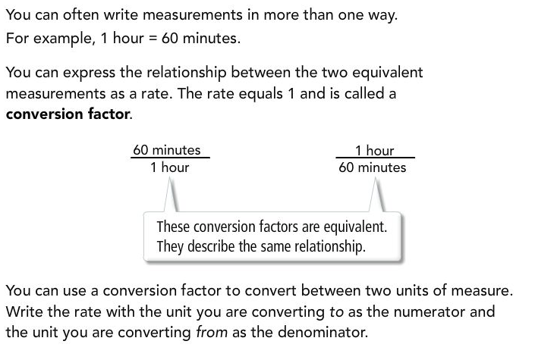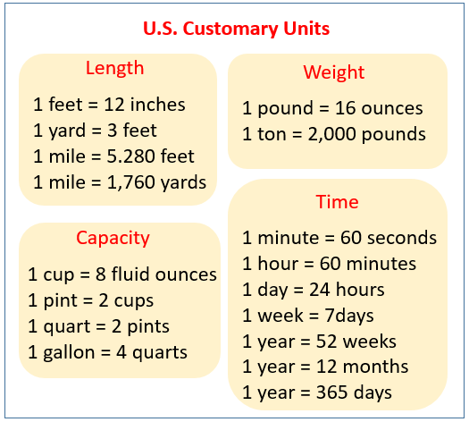
Example: Convert 29 feet to yards.
Set up your equation to multiply 29 times the to/from conversion factor. I am converting to yards/ from feet, so my conversion factor would be 1 yard/3 feet.
29 x 1/3 = 29/3 = 9 2/3 yards

Let’s say that you had 9 2/3 yards and you wanted to convert to feet instead. Set up your equation to multiply 9 2/3 times the to/from conversion factor. This time I am converting to feet/from yards, so my conversion factor would flip to 3 feet/1 yard.
9 2/3 x 3/1 = 29/3 x 3/1 = 29 feet
The conversion factor is a rate that can be multiplied by one type of unit to convert it to another unit of measurement.

Part 1: Choose the conversion factor on the right to complete each equation. The correct conversion factor in each situation is the one that has the new units in the numerator (to) and the original units in the denominator (from).
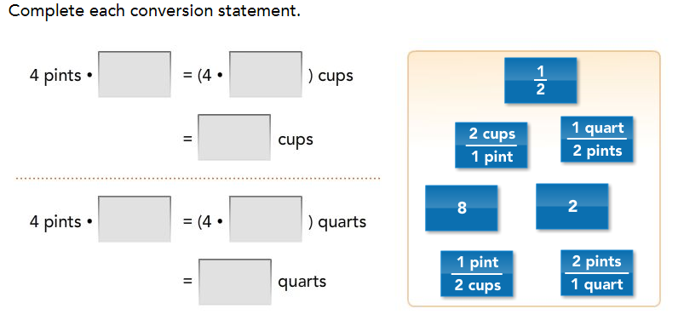
Got it? Do the Part 1 Got It problem on pg. 276 (Use 1 cup = 8 fluid ounces)

Part 2:
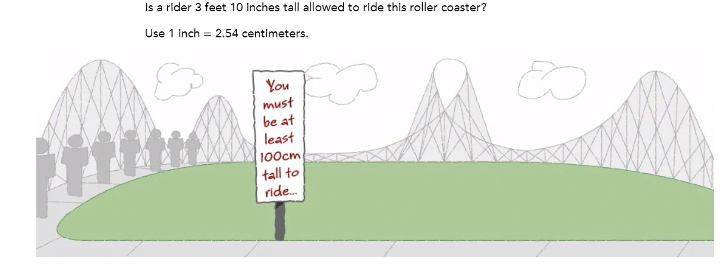
Got It? Do the Part 2 Got It problems on pg. 276 and 277
Part 3:
A bread recipe calls for 500 grams of flour. About how many pounds of flour do you need?
Use 𝟣 𝗈𝗎𝗇𝖼𝖾 ≈ 𝟤𝟪.𝟦 𝗀𝗋𝖺𝗆𝗌 (1 ounce is almost equal to 28.4 grams)

Got It? Do the Part 3 Got It problem on pg. 277 and Close and Check on pg. 278

Lesson 11-4 Homework
Measurements and Ratios

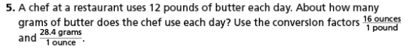

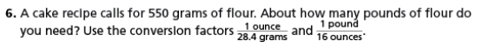

Lesson 11-5 Choosing the Appropriate Rate
First do the Launch Activity on pg.279 of your Digits Student Companion Workbook.
Key Concept
Given any two measurements, you can write two different rates to compare them.
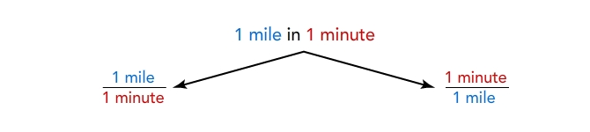
Notice that the two rates are reciprocals.
For any given problem, you must decide which rate to use or choose the appropriate rate for a situation.

Part 1:
The recommended rate for a scuba diver to come to the surface is 30 feet per minute. What is the rate in seconds per foot?

Got It? Do the Part 1 Got It problem on pg 280

Part 2:
On your friend’s current phone plan, text messages cost 10¢ per message. Which of the following plans offer a better deal than the current plan?
(Hint: Make sure that you are comparing using the same rate; you may need to convert some units)
Plan A | Plan B | Plan C | Plan D | Plan E
$2 for 20 messages | 10 messages per dollar | $5 for 100 messages | 1 message for 5 cents | 70 messages for $7

Got It? Do the Part 2 Got It problem on pg. 280

Part 3:
You get an offer to baby-sit for $6.25 per hour.
a. How much will you earn if you baby-sit for 5 hours?

b. How many hours will you need to baby-sit at this rate to earn $100?

Got It? Do the Part 3 Got It problem on pg. 281 and Close and Check on pg. 282

Lesson 11-5 Homework
Choosing the Appropriate Rate

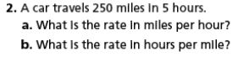

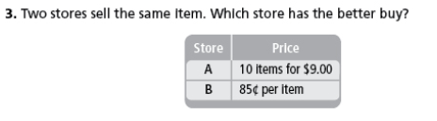

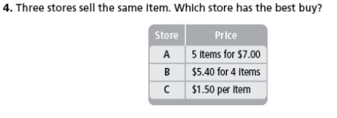

Lesson 11-6 Problem Solving
First do the Launch Activity on pg.283 of your Digits Student Companion Workbook.

Part 1:
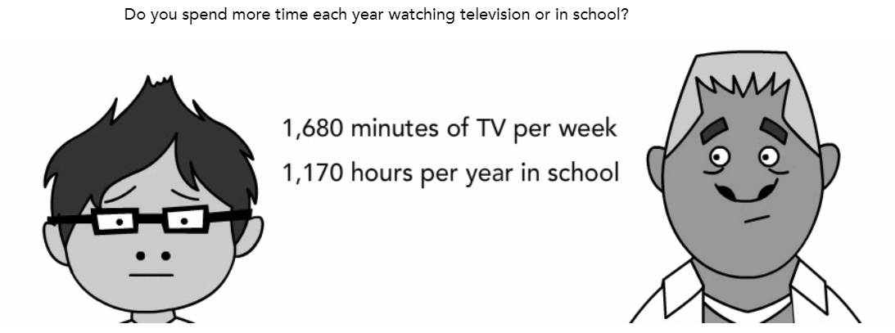
(Hint: Convert units to make the rates match for comparing)

Got It? Do the Part 1 Got It problem on pg. 284

Part 2:
Mrs. Lott and her husband want to find out how much water they use in their bathroom each day. Her husband takes a 5‑minute shower each day, she takes 1 bath each day, and they flush the toilet a total of 6 times each day. How much water do the Lotts use per week in the bathroom?
Water Source | Water Use Rate
Bathtub | 35 gallons per bath
Shower | 2.2 gallons per minute
Toilet | 1.5 gallons per flush

Got It? Do the Part 2 Got It problem on pg. 284 and Close and Check on pg. 285
Lesson 11-6 Homework
Problem Solving
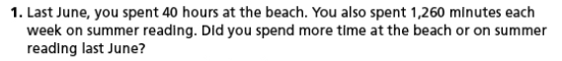

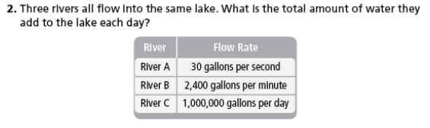

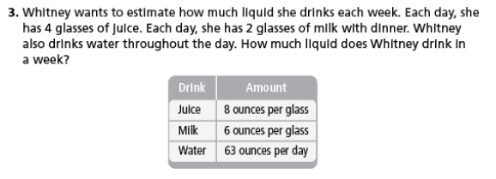Show Ans
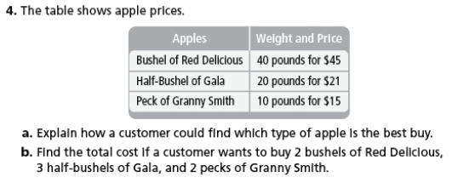

Name: ___________________# ___________ Due: May 15, 2020
Week 3 Nadeau 6th Grade ELA Distance Learning
Excerpt from “Roll of Thunder, Hear My Cry” by Mildred D. Taylor StudySync Student Companion pgs. 256-259
- Which paragraph provides the first reference to the issue troubling Papa and his family?
A. Paragraph 4
B. Paragraph 6
C. Paragraph 9
D. Paragraph 11
- What is most closely the meaning of amenities as it is used in the following passage (paragraph 22)?
You goin’ up to the store tomorrow, David? Mr. Avery asked after all the amenities had been said. Since the first trip in January, Mr. Morrison had made one other trip to Vicksburg, but Papa had not gone with him.
A. noun | requirements
B. noun | greetings
C. noun | features
D. noun | insults
- Which sentence from the following passage best supports the idea that the family is upset by Mr. Avery’s news (paragraphs 24-26)?
Mr. Avery cleared his throat nervously. “It’s—it’s that list I come ’bout, David. . . . I don’t want them things no more.”
The porch grew silent.
When no one said anything, Mr. Avery glanced at Mr. Lanier, and Mr. Lanier shook his head and continued. “Mr. Granger making it hard on us, David. Said we gonna have to give him sixty percent of the cotton, ’stead of fifty . . . now that the cotton’s planted and it’s too late to plant more. . . . Don’t s’pose though that it makes much difference. The way cotton sells these days, seems the more we plant, the less money we gets anyways—”
A. “Mr. Avery cleared his throat nervously.”
B. “The porch grew silent.”
C. “’Mr. Granger making it hard on us, David.’”
D. “’Don’t s’pose though that it makes much difference.’”

- Papa tells Stacey he is “born blessed” mainly because .
A. he is able to work
B. he has a family
C. he has land
D. he is a boy

- Papa’s feelings toward Mr. Avery and Mr. Lanier are best described as .
A. disappointment
B. anger
C. understanding
D. relief
- Which theme in the text is mainly expressed by the final paragraph?
Papa looked down at me and brought me closer, then waved his hand toward the drive. “You see that fig tree over yonder, Cassie? Them other trees all around . . . that oak and walnut, they’re a lot bigger and they take up more room and give so much shade they almost overshadow that little ole fig. But that fig tree’s got roots that run deep, and it belongs in that yard as much as that oak and walnut. It keeps on blooming, bearing good fruit year after year, knowing all the time it’ll never get as big as them other trees. Just keeps on growing and doing what it gotta do. It don’t give up. It give up, it’ll die. There’s a lesson to be learned from that little tree, Cassie girl, ’cause we’re like it. We keep doing what we gotta, and we don’t give up. We can’t.”
A. People must keep trying so they can succeed.
B. Lessons can be learned in the most unusual places.
C. Nature creates trees with many different functions.
D. Family has the ability to provide security and comfort.
- Which passage from the last paragraph of the excerpt most directly supports the answer to Question 7?
A. “Papa looked down at me and brought me closer…”
B. “‘You see that fig tree over yonder, Cassie?’”
C. “'…it belongs in that yard as much as that oak and walnut.'”
D. “‘We keep doing what we gotta, and we don’t give up.’”

Week 3 Writing Prompt
The author constructs this text as a series of dialogues (characters speaking to one another). Think about the content (the things they say) and tone (the way they say it) of Papa’s conversations with Mama, Cassie, Stacey, and the neighbors. In an essay of at least 250 words, explore their impact on the excerpt.

During Week 4, you will be writing your own narrative. Use the following Narrative Framework and Checklist to help you plan your Narrative.
