7th Grade & MA Science Week 3
Read the information on Wegener’s Theory of Plate Tectonics and answer the questions. I have attached a page for the terms and questions that you can download, complete, and send back to me.
Assignments can be emailed to me as an attachment or take a photo of completed work and email me at drowe@tusd.net or deliver to school. Online work can be submitted at anytime until May 15. May 15 is the drop off day for paper work. Be sure to put name on all work submitted. If you have any questions or concerns my office hours will be daily, Monday-Friday, 10:30- 11:30 and 1:30-2:30 by email.

Alfred Wegener Story

Perhaps Alfred Wegener’s greatest contribution to the scientific world was his ability to weave seemingly dissimilar, unrelated facts into a theory, which was remarkably visionary for the time. Wegener was one of the first to realize that an understanding of how the Earth works required input and knowledge from all the earth sciences.
Wegener’s scientific vision sharpened in 1914 as he was recuperating in a military hospital from an injury suffered as a German soldier during World War I. While bed-ridden, he has ample time to develop an idea that had intrigued him for years. Like others before him, Wegener had been struck by the remarkable fit of the coastlines of South America and Africa. But, unlike the others, to support his theory Wegener sought out many other lines of geologic and paleontologic evidence that these two continents were once joined. During his long convalescence, Wegener was able to fully develop his ideas into the Theory of Continental Drift, detailed in a book titled The Origin of Continents and Oceans published in 1915.
Wegener obtained his doctorate in planetary astronomy in 1905 but soon became interested in meteorology; during his lifetime, he participated in several meteorologic expeditions to Greenland. Tenacious by nature, Wegener spent much of his adult life vigorously defending his theory of continental drift, which was severely attacked from the start and never gained acceptance in his lifetime. Despite overwhelming criticism from most leading geologists, who regarded him as a mere meteorologist and outsider meddling in their field, Wegener did not back down but worked even harder to strengthen his theory.
A couple of years before his death, Wegener finally achieved one of his lifetime goals: an academic position. After a long but unsuccessful search for a university position in his native Germany, he accepted a professorship at the University of Graz in Austria. Wegener’s frustration and long delay in gaining a university post perhaps stemmed from his broad scientific interests. As noted by Johannes Georgi, Wegener’s longtime friend and colleague, “One heard time and again that he had been turned down for a certain chair because he was interested also, and perhaps to a greater degree, in matters that lay outside its terms of reference—as if such a man would not have been worthy of any chair in the wide realm of world science.”
Ironically, shortly after achieving his academic goal, Wegener died on a meteorologic expedition to Greenland. Georgi had asked Wegener to coordinate an expedition to establish a winter weather station to study the jet stream (storm track) in the upper atmosphere. Wegener reluctantly agreed. After nay delays due to severe weather, Wegener and 14 others set out for the winter station in September of 1930 with 15 sledges and 4,000 pounds of supplies. The extreme cold turned back all but one of the 13 Greenlanders, but Wegener was determined to push on to the station, where he knew the supplies were desperately needed by Georgi and the other researchers. Travelling under frigid conditions, with temperatures as low as -54 ^{ₒ}C, Wegener reached the station five weeks later. Wanting to return home as soon as possible, he insisted upon starting back to the base camp the very next morning. But he never made it; his body was found the next summer.
Wegener was still an energetic, brilliant researcher when he died at the age of 50. A year before his untimely death, the fourth revised edition (1929) of his classic book was published; in this edition, he had already made the significant observation that shallower oceans were geologically younger. Had he not died in 1930, Wegener doubtless would have pounced upon the new Atlantic bathymetric data just acquired by the German research vessel Meteor in the 1920’s. These data showed the existence of a central valley along much of the crest of the Mid-Atlantic Ridge. Given his fertile mind, Wegener just possibly might have recognized the shallow Mid-Atlantic Ridge as a geologically young feature resulting from thermal expansion, and the central valley as a rift valley resulting from stretching of the oceanic crust. From stretched, young crust in the middle of the ocean to seafloor spreading and plate tectonics would have been short metal leaps for a big thinker like Wegener. This conjectural scenario by Dr. Peter R. Vogt (U.S. Naval Research Laboratory, Washington, D.C.), an acknowledged expert on plate tectonics, implies that “Wegener probably would have been part of the plate-tectonics revolution, if not the actual instigator, had he lived longer.” In any case, may of Wegener’s ideas clearly served as the catalyst and framework for the development of the theory of plate tectonics three decades later.

ALFRED LOTHAR WEGENER

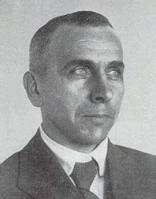
Alfred Wegener (1880 - 1930)
Wegener was a German meteorologist, geophysicist and polar researcher. In 1915 he published ‘The Origin of Continents and Oceans’, which outlined his theory of Continental Drift.
Wegener was a member of four expeditions to Greenland. In 1930 he visited Greenland for the last time, where he died shortly after his fiftieth birthday.
Wegener’s theory of Continental Drift was met with scepticism by many scientists. Although he had a lot of evidence to support the theory, he could not explain how the plates moved. It would be almost half a century before this problem began to be solved.
Wegener supported his Continental Drift idea with 5 lines of evidence: Jigsaw Fit, Geologic Fit, Tectonic Fit, Glacial Deposits, and Fossil Evidence.

JIGSAW FIT
The similarity in outline of the coastlines of eastern South America and West Africa had been noted for some time. The best fit is obtained if the coastlines are matched at a depth of 1,000 metres below current sea level.

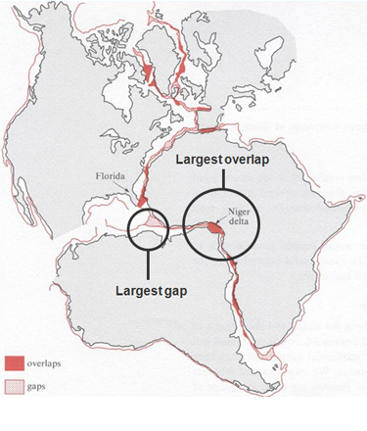
Eastern South American and West African
coastlines show the best jigsaw fit
Image: from OU S267 How The Earth Works: Block 2 How Plate Tectonics Works p7
Any areas where there are gaps or overlaps may be explained by :
- Coastal erosion since continental separation
- Coastal deposition since continental separation
- Rises in sea level (eustatic change) since continental separation
- Changes in land level (isostatic change) since continental separation

GEOLOGICAL FIT
When the geology of eastern South America and West Africa was mapped it revealed that ancient rock outcrops (cratons) over 2,000 million years old were continuous from one continent to the other.

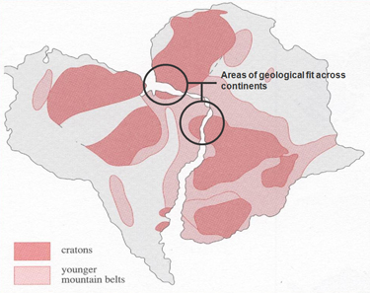
Geological fit of opposing
continental coastlines
Image: From OU S267 How The Earth Works: Block 2 How Plate Tectonics Works p10

TECTONIC FIT
Fragments of an old fold mountain belt between 450 and 400 million years ago are found on widely separated continents today. Pieces of the Caledonian fold mountain belt are found in Greenland, Canada, Ireland, England, Scotland and Scandinavia. When these land masses are re-assembled the mountain belt forms a continuous linear feature.

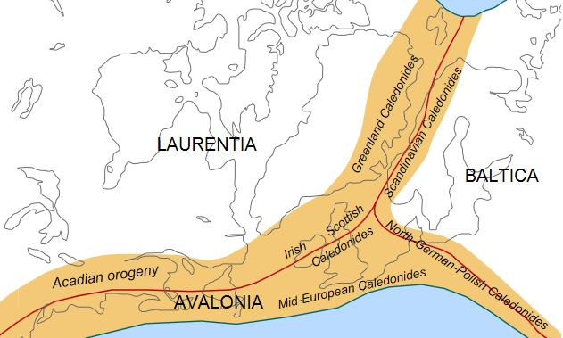
Caledonian/Acadian mountain belts at the end of the Caledonian. Present day coastlines in grey.

TECTONIC FIT
Fragments of an old fold mountain belt between 450 and 400 million years ago are found on widely separated continents today. Pieces of the Caledonian fold mountain belt are found in Greenland, Canada, Ireland, England, Scotland and Scandinavia. When these land masses are re-assembled the mountain belt forms a continuous linear feature.

Caledonian/Acadian mountain belts at the end of the Caledonian. Present day coastlines in grey.

FOSSIL EVIDENCE
There are many examples of fossils found on separate continents and nowhere else, suggesting the continents were once joined. If Continental Drift had not occurred, the alternative explanations would be:
- The species evolved independently on separate continents – contradicting Darwin’s theory of evolution.
- They swam to the other continent/s in breeding pairs to establish a second population.
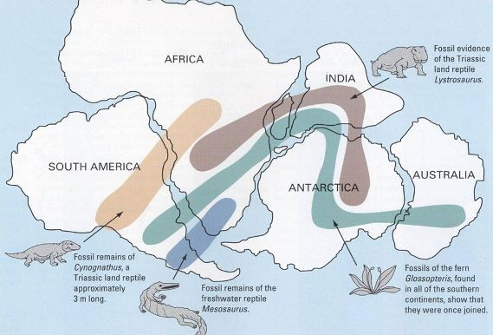
Image: From This Dynamic Earth: The Story of Plate Tectonics p8
Remains of Mesosaurus, a freshwater crocodile-like reptile that lived during the early Permian (between 286 and 258 million years ago), are found solely in Southern Africa and Eastern South America. It would have been physiologically impossible for Mesosaurus to swim between the continents. This suggests that South America and Africa were joined during the Early Permian.
Cynognathus is an extinct mammal-like reptile. The name literally means ‘dog jaw’. Cynognathus was as large as a modern wolf and lived during the early to mid Triassic period (250 to 240 million years ago). It is found as fossils only in South Africa and South America.
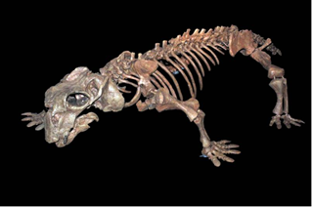
Lystrosaurus
Lystrosaurus - which literally means ‘shovel reptile’ - was dominant on land in the early Triassic, 250 million years ago. It is thought to have been herbivorous and grew to approximately one metre in length, with a stocky build like a pig. Fossils of Lystrosaurus are only found in Antarctica, India and South Africa.
Glossopteris was a woody, seed-bearing shrub or tree, named after the Greek descripton of ‘tongue’ – a description of the shape of the leaves. Some reached 30m tall. It evolved during the Early Permian (299 million years ago) and went on to become the dominant species throughout the period, not becoming extinct until the end of the Permian. Fossils are found in Australia, South Africa,South America, India and Antarctica.
When the continents of the southern hemisphere are re-assembled into the single land mass of Gondwanaland, the distribution of these four fossil types form linear and continuous patterns of distribution across continental boundaries.

