Mrs. Nadeau’s 6th Grade Distance Learning Assignments
Week 4 : May 11th thru May 15th
Daily Work Expectation: 2-3 hours per day of schoolwork
Daily Office Hours:  M W F 9:00am to 11:00am T TH 2:00pm to 4:00pm  Contact Info: mailto:cnadeau@tusd.net  Text: 925-487-2068 (no phone calls please) |  | Zoom Class Meetings Wednesday @ 2:30  (attendance not required)  Video Chat available in Microsoft Teams during my office hours for one on one or small group instruction as needed.
Materials and Resources | Required Links for Digital Option 🖳  🖳 Digits: http://mymathuniverse.com/  🖳 StudySync: https://connected.mcgraw-hill.com/  🖳 Office 365: https://login.microsoftonline.com/  Digital Work should be submitted for grading immediately. | Required Materials for Paper Option ✍  ✍ Math- Digits Student Companion  ✍ StudySync Reading and Writing Companion  ✍ Week 4 Packet contains Suggested Pacing Guide Math, ELA Comprehension Quiz, Writing Prompt, and Science  **Carefully tear out all completed companion pages, stack them with other completed print materials, and any work you have done on notebook paper, staple in the top left, and write your NAME and WEEK NUMBER in the top right.
Math  *Rates | 🖳 Digits: http://mymathuniverse.com/  - Topic 11 Review and Topic 11 Review Homework  - Topic 11 Test  - Lesson 12-1 Plotting Ratios and Rates and 12-1 Homework  - Lesson 12-2 Recognizing Proportionality and 12-2 Homework | ✍ Math Packet and Digits Student Companion  For each lesson, the Launch, Got Its, and Close and Check are in the Companion. Key Concepts, examples, additional practice, and homework are in the packet. Follow the sequence in your Math Packet for Week 4.  - Topic 11 Review Pull It All Together Task 1 and 2 Companion pg. 288 and Topic 11 Review Homework  - Topic 11 Test  - Lesson 12-1 Plotting Ratios and Rates and 12-1 Homework  - Lesson 12-2 Recognizing Proportionality and 12-2 Homework
ELA  *Reading and Writing Narratives  *Dialogue | 🖳 StudySync: https://connected.mcgraw-hill.com/  - “Children of the Dustbowl” by Jerry Stanley Intro, Vocabulary, and First Read with Annotations (at least 5)  - " Children of the Dustbowl” Comprehension Quiz  - " Children of the Dustbowl” Close Read: Read a 2nd time  - " Children of the Dustbowl”” Think Questions: Restate questions/ respond completely. Cite evidence where appropriate.  - Writing: You will be writing your Narrative in StudySync from the “Write” tab. Use your Narrative Writing Framework and Checklist from Week 3. | ✍ StudySync Companion and Handout  - Read “Children of the Dust Bowl” by Jerry Stanley Intro pg. 261  - Vocabulary- Define these terms before reading: epidemic, opposition, rejection, sanitation, and shiftless  - Complete First Read “Children of the Dust Bowl” pgs. 262-264 with annotations (at least 5)  - Reading Comprehension Quiz (packet)  - Respond to Think Questions pg. 264. Use lined notebook paper, restate questions, and write complete responses with evidence where appropriate.  - Writing: You will be writing your own Narrative (story) on lined notebook paper. Use your Narrative Framework and Checklist from Week 3.
Science  *Cell Structure and Function | 🖳Office 365 https://login.microsoftonline.com/  Science materials emailed to you  - Read: “What Do Cells Do?”  - Answer Questions 1-15 “What Do Cells Do?”  - Use the Plant and Animal Cell Diagrams to Label the Typical Plant and Typical Animal Cell Diagrams correctly  - Venn Diagram: Compare and Contrast Plant and Animal Cells (at least 5 similarities and 5 differences for each) | ✍ Week 4 Packet  - Read: “What Do Cells Do?”  - Answer Questions 1-15 “What Do Cells Do?”  - Use the Plant and Animal Cell Diagrams to Label the Typical Plant and Typical Animal Cell Diagrams correctly  - Venn Diagram: Compare and Contrast Plant and Animal Cells (at least 5 similarities and 5 differences for each)
Reading | Read 30 minutes (or more!) per day – use the ATTACHED LOG to record your reading!
PE/STEAM | Email PE Exercise Logs to mbeck@tusd.net and STEAM work can be shared with Mr. Adams online or email to dadams@tusd.net by May 15th.
Week 3 and Week 4 Assignments are Due this Friday, May 15th.
Week 4 Suggested Pacing for Distance Learning -Mrs. Nadeau’s 6th Grade Class
 | Monday 5/11 | Tuesday 5/12 | Wednesday 5/13 | Thursday 5/14 | Friday 5/15  Week 3 and Week 4  Assignments Due
Reading/  Language Arts | Read 30-40 min. & Log  StudySync “Children of the Dust Bowl”  - Intro/Vocabulary  - 1st Read with Annotations  - Comp. Quiz (Looking back at text)  Planning Your Own Narrative: Use the Narrative Framework and Checklist | Read 30-40 min & Log.  StudySync “Children of the Dust Bowl”  - Close Read  - Watch SyncTV Discussion (Digital Only)  Drafting Your Own Narrative (StudySync Write tab for digital ) | Read 30-40 min. & Log  StudySync “Children of the Dust Bowl”  - Think Questions  Drafting Your Own Narrative continues | Read 30-40 min. & Log  StudySync “Children of the Dust Bowl”  Revise and Proofread Your Narrative: Use the checklist provided and make changes as needed | StudySync “Children of the Dust Bowl”  Finalize your Narrative StudySync and submit for grading  - 2 peer Reviews (Digital Only)
Math | Digits Topic 11 Review and Homework  Rates | Digits Topic 11 Test  Rates | Digits Lesson 12-1 and Homework  Plotting Ratios and Rates | Digits Lesson 12-2 and Homework  Recognizing Proportionality | No Math: Spend more time on your Narrative Writing
Science | Read “What Do Cells Do?”  Answer Questions 1-15 “What Do Cells Do?” | Label Typical Plant Cell Diagram  *Use the diagram provided to label your own correctly | Label Typical Animal Cell Diagram  *Use the diagram provided to label your own correctly | Venn Diagram: Compare and Contrast Plant and Animal Cells  *Include a minimum of 5 similarities, 5 features unique to Plant Cells, and 5 features unique to animal cells
May Dos | Prodigy | Prodigy | Prodigy | Prodigy | Prodigy
The expectation is to spend 2-3 hours per day on school work. Take breaks as needed and reach out for help as needed.

Name: ___________________________#______ Week #: ______
Reading Log
6th Grade
Each week, you are required to read for a minimum of 30 minutes each day (Monday-Thursday) or 120 minutes per week. Of course, you can always read more! Each day log the number of minutes read and write 1-2 sentences summarizing the key details from your reading.
Date | Title | Minutes Read | Key Details from today’s reading | Parent Signature

Name: _____________________________#______Due Date: May 15th
Week 4 Nadeau Math Distance Learning
Topic 11 Review: Rates
To review what you have learned in this topic, first complete Task 1 and Task 2: Pull It All Together in Digits Student Companion pg. 288
Topic 11 Review Homework
- A box of dried fruits has 72 calories in 4 servings. How many calories are there per serving?

- A 3-pound bag of wildflower seed covers 12 square feet. How many pounds of seed does it take to cover 1 square foot?

- A plant grew 7 inches over 5 months. The plant grows the same amount each month. Use this rate to complete the table.
Month | Growth  (in inches)
1
2
3
4
5 | 7
6

- An airplane on autopilot took 8 hours to travel 5,576 kilometers. What is the unit rate for kilometers per hour?

- If 6 pens cost $3.90, what is the unit price of the pens?

- You want to buy some beans. A 7-ounce package costs $2.38, a 12-ounce package cost $3.84, and a 22-ounce package costs $7.26. Which package is the best buy?

- Every morning Jenna runs for 15 minutes. If Jenna runs 8 miles per hour, how far does she travel? Use the equation d=rt where d is the distance, r is the rate, and t is the time.

- A horseback rider travels 2 miles in 12 minutes. At this speed, how long does it take to travel 3 miles? Use the equation d=rt where d is the distance, r is the rate, and t is the time.

- Complete the conversion. Use the rate suggested by the equation 1 qt = 2 pints.
14 pints = _______qts.

- Convert 14 inches to centimeters. Use the conversion factor 2.54cm/1 in.

- A car travels 600 miles in 12 hours. What is the rate in miles per hour? In hours per mile?

- You finish 2 homework problems in 10 minutes. Your friend finishes 4 homework problems in 1/3 of an hour. Are you and your friend working at the same rate? Explain.

Topic 11 Test
- In one week, 16 hens laid 80 eggs. What is the unit rate for eggs per hen?

- An animal gained 4 kilograms steadily over 20 years. What is the unit rate of kilograms per year?

- Six model cars cost $30, what is the unit price of the model cars?

- A 20-pound bag of cat food costs $14.60. A 25-pound bag of the same cat food costs $18.50. Which bag of cat food is the better buy?

- A delivery driver traveled 48 miles per hour. It took 4 hours to travel the distance between two towns. What is the distance between the two towns? Use the equation d=rt where d is the distance, r is the rate, and t is the time.

- On a school field trip, the bus travels 15 miles in 30 minutes. Find the speed of the bus in miles per hour. Use the equation d=rt where d is the distance, r is the rate, and t is the time.

- Convert 28 yards to feet. Use the rate suggested by the equation 3 feet = 1 yard.

- A river flows at the rate of 4 miles per hour. What is the rate in minutes per mile?

- A worker earns $12.50 per hour. For how many hours would the worker have to work to earn $350?

- Beach A has 7,400 visitors per day. Beach B has 61,600 visitors every 2 weeks. Which beach has more visitors?
Lesson 12-1 Plotting Ratios and Rates
First, Do the 12-1 Launch on pg. 289 of your Digits Companion.
Key Concept
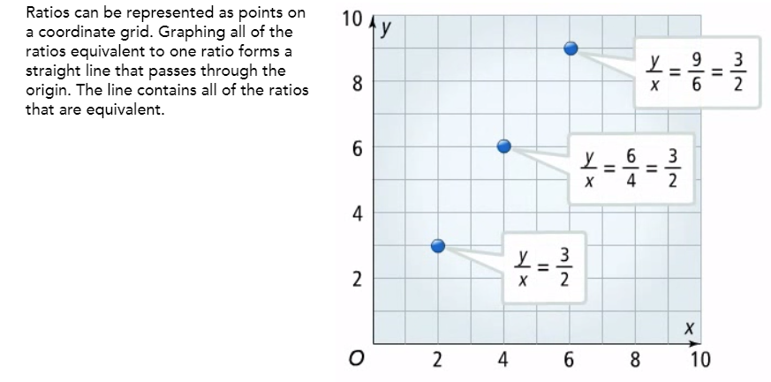
Above, the terms of the ratios are assigned to the variables x and y, the ratio is written as a fraction with y/x. Equivalent ratios are written in the same manner, then (x,y) coordinates are graphed. For example: y to x is written as y/x; if y = 3 and x = 2, then y/x =3/2. In addition, all fractions equivalent to 3/2 are also equivalent to y/x.
Lesson 12-1 Part 1:
A radio station plays 2 minutes of commercials for every 20 minutes. Complete the table and graph the ratios.
Commercials (in minutes) x | Music  (in minutes) y
2 | 20
4
6
8
10
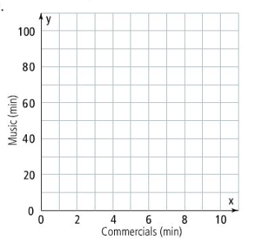
Got It? Do Part 1 Got It problem on pg. 290
Lesson 12-1 Part 2:
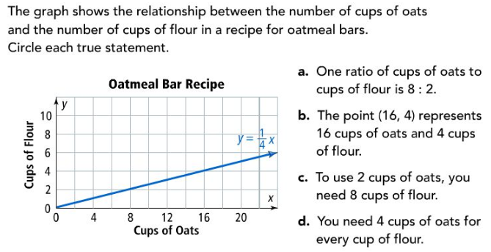
Part 2: Example 2
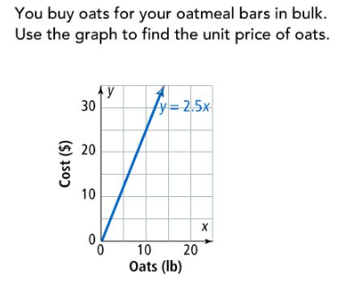
The unit price of oats is $_________
Got It? Do the Part 2 Got It problem on pg. 291
Lesson 12-1 Part 3:
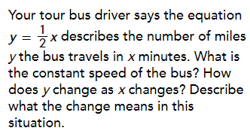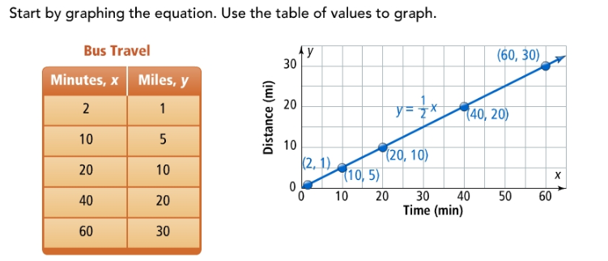
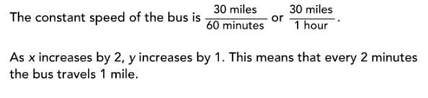
Got It? Do Part 3 Got It problem on pg. 291
Lesson 12-1 Homework
- A student runs 4 minutes for every 12 minutes he walks. Complete the table and graph the ratios. Be sure to label your x- and y-axes and connect the points as shown in the lesson.
Exercise Times
Running (Minutes) x | 4 | 8 | 12 | 16 | 20
Walking (Minutes) y | 12
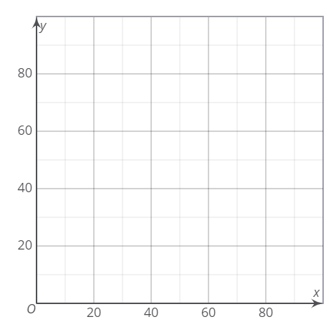
- You buy flour in bulk for a recipe. What is the unit price of the flour based on the graph?
$_____/pound
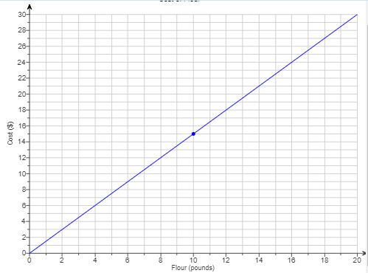
- The equation y = 1/3x describes the number of calls y a salesperson makes in x minutes. How does y change as x changes? Describe what the change means in this situation.

- For a reading contest, a teacher awards 6 gold stars for every 18 books read. Complete the table and graph the ratios.
Reading Awards
Gold Stars Awarded | 6 | 12 | 18 | 24 | 30
Books Read | 18

Now, Graph the ratios from #4 table on the graph below. Be sure to label the x- and y- axes.
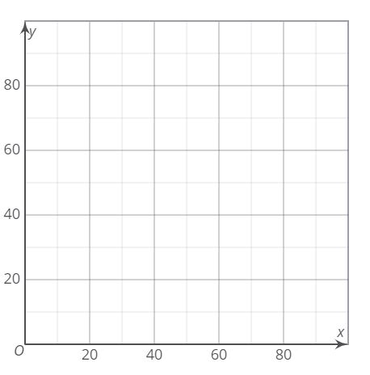
- Think about the process: You buy 20 juice boxes for $8.20. What steps should you take to find the unit price using the graph? What is the unit price?
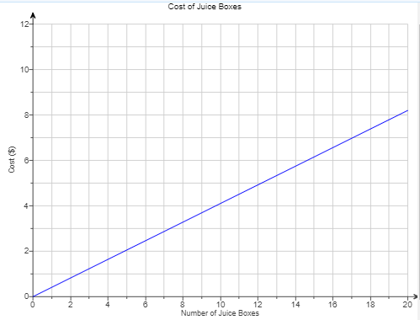
Lesson 12-2 Recognizing Proportionality
First, Do the 12-2 Launch on pg. 293 of your Digits Companion.
Key Concepts
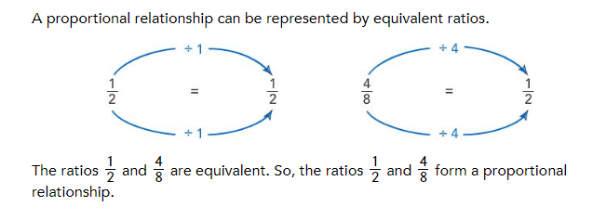
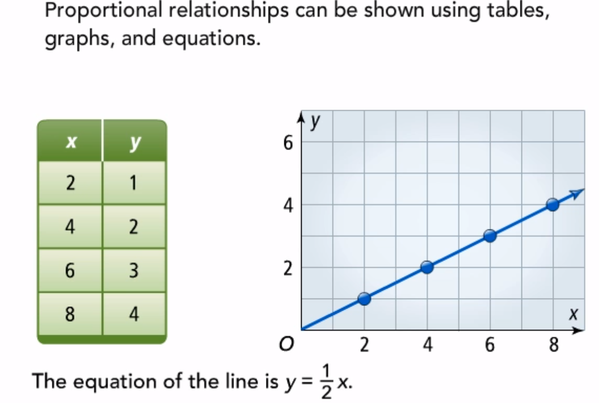
12-2 Part 1
Tell whether each pair of ratios form a proportional relationship. Remember, if they are equivalent fractions, they are proportional.
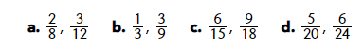
Got It? Do the Part 1 Got It problem on pg. 294
12-2 Part 2
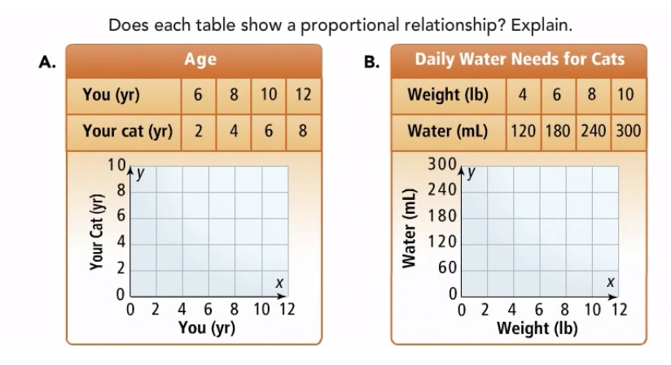
Got It? Do the Part 2 Got It problem on pg. 294
12-2 Part 3
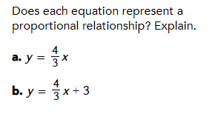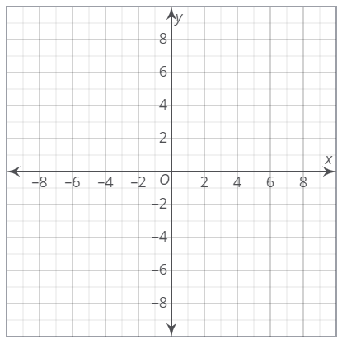
*Replace x in each equation, then solve for y. Use simple numbers like 1, 2, 3, 4. Make a table to keep track of x and y, these will be your coordinates for your graph. To represent a proportional relationship, the graph of the equation must pass through (0, 0) and be a straight line.
Got It? Do Part 3 Got It problem on pg. 295 and 12-2 Close and Check on pg. 296
Name___________________________Date:________________
Week 4 ELA: StudySync
Comprehension Quiz for “Children of the Dust Bowl” by Jerry Stanley
Directions: Read each question carefully and choose the best answer. Look back at the text as needed.
- Which of these selections most likely explains why the author includes the following detail from Chapter 4?
“Okie use’ ta mean you was from Oklahoma,” an Okie says in The Grapes of Wrath. “Now it means . . . you’re scum.”
A. To show how no one knew where the Okies were from when they arrived in California
B. To show how Oklahomans behaved worse when they arrived in California
C. To support the idea that ‘Okie’ became a negative term
D. To prove that ‘Okie’ meant you lived in California

- Which of the following reasons best explains why Californians treated the Okies poorly?
A. Local residents were annoyed that they were forced to leave the state.
B. Parents were angry that the Okies wanted to open their own separate school.
C. Students were jealous of how far ahead the Okie children were in school
D. Taxpayers were angry at all of the resources Okies used up.

- What is most likely the author’s purpose by mentioning that Leo Hart appeared “as if he knew some great secret” in Paragraph 4?
A. To show that Leo had a dark past
B. To suggest that Leo would never tell those close to him about his involvement with the Okies
C. To warn that Leo was going to hurt the Okies
D. To suggest that Leo was plotting some way to help the Okie children

- In Chapter 6, which of the following statements about the “the emergency” is best supported by the following passage?
Leo told the president of the board that he wanted to remove the Okie children from the public school. The president enthusiastically agreed. Then Leo asked him to declare that an emergency existed. “The emergency,” Leo said, “was overcrowding in the public schools.” Knowing that the president was willing to consider any idea that might solve what he thought of as the Okie problem, Leo asked him for permission to build an “emergency school” for Okie children “at no expense to the district.” Swiftly the president granted permission—without asking where the school might be located or how it might come about.
A. There was really no emergency in the local schools.
B. The main emergency being addressed was the poor quality of clothing the Okie students showed up to school in.
C. The president did not think there was an emergency in the schools.
D. The emergency status made it possible for the new school to be built without further angering locals and officials.

- Which statement about Leo Hart is best supported by the text?
A. He believed that every child deserved a fair shot in life.
B. He had longstanding frustrations with the people of California before the Okies even arrived.
C. He was originally one of the locals who had insulted the Okies.
D. He had been in search of a major project of his own when he connected with the Okie children.

- Which sentence from the text most strongly supports the answer to Question 5?
A. “I could never understand why they shouldn’t be given the same opportunity as others.”
B. “When they went to school each day, most of the teachers ignored the migrants, believing that Okie kids were too stupid to learn the alphabet, too dumb to master math.”
C. “He was forty years old at the time, but it did not seem unusual to the children that this tall, slender man came to their makeshift playground at least once a week.”
D. “But on this day Leo was phoning to tell the school board just what it wanted to hear.”

- Which inference about the Leo Hart is best supported by the text?
A. He was one of the most despised men in Kern County.
B. He wanted desperately to find a way for the Okie children to succeed in the schools they were already in.
C. He was not that deeply affected by the struggles of the Okie children.
D. He designed the school to teach the Okies useful subjects and skills that built upon their strengths.

- Which sentence from the text most strongly supports the answer to Question 7?
A. “Edna Hart recalled that her husband would come home from work so upset that he couldn’t eat or sleep.”
B. “It would teach practical skills, such as masonry, mechanics, and agriculture.”
C. “He was a caring man who always had a smile on his face, as if he knew some great secret no one else knew.”
D. “But the feeling of rejection was greatest among Okie children.”

- Order these events chronologically as they occur in the story:
  - The superintendent approves a separate school for Okies.
  - Leo has an idea that would remove Okie children from the schools they were in.
  - Leo discovers Okie children are being mistreated.
  - An overcrowding emergency is declared in Kern County schools.
FIRST | SECOND | THIRD | FOURTH

- Match each vocabulary word with its corresponding definition:
- sanitation
- shiftless
- opposition
- epidemics
- rejection
Definition | Word
Act of maintaining cleanliness
Situations with widespread disease
Lazy
Resistance
Refusal

Writing Week 4
Think about the narratives you have read over the last 4 weeks. Look back at your Narrative Framework and Checklist from Week 3. Now, write your Narrative (story) in which you do the following:
* Describe Main Characters and the Setting
* Create a basic plot with a clear beginning introducing a problem, middle where characters go through action and events to solve the problem, and ending that resolves the problem (Make something happen to someone)
* Hook and Satisfy the reader (Start and end your story intentionally)
* Describe the action (Use sensory details to develop key moments)
* Revise and Edit your final work to be shared and graded

