Lesson 10-1 Homework

- Use the protractor to find the measure of ∠BAD.
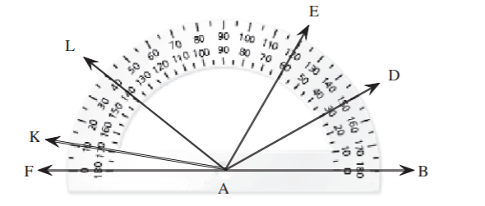

- Use the protractor to find the measure of ∠FAE.
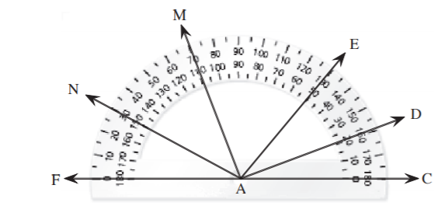

- Classify the angle as right, straight, acute, or obtuse.
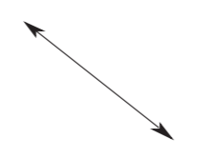

- Which of the given angles is an obtuse angle?
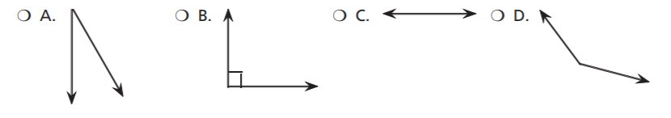

- The measure of ∠1 is (3x – 75)°. Find the value of x.
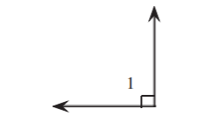

- The measure of ∠ABC is 60°. Find the value of x.
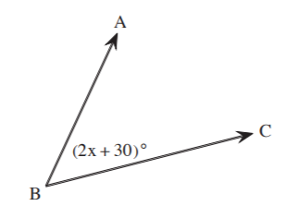

- Use the protractor to find the measure of ∠BAD. Identify if ∠BAD is acute, right, straight, or obtuse.
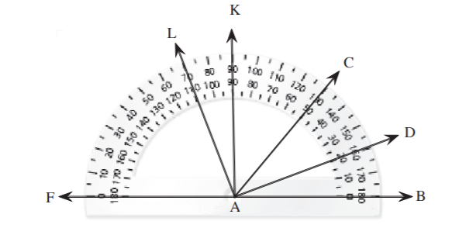

- The measure of ∠ABC is 55°. Find the value of x.
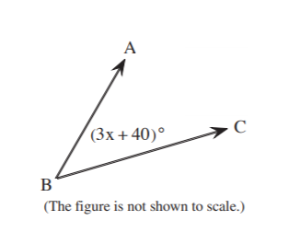

- A flagpole is at a (4x + 2)° angle from the ground. Find the value of x.
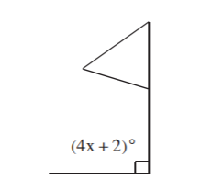

- The measure of ∠1 is (5x + 30)°. Find the value of x.
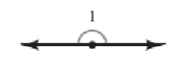

- Find the measure of ∠BAG.
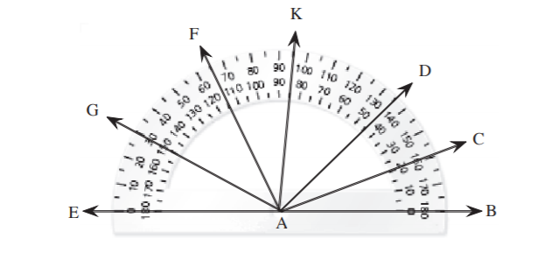

Lesson 10-2 Homework

- Check each angle that is adjacent to ∠w.
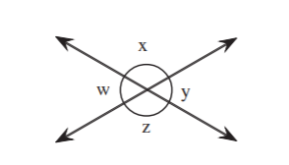
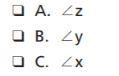

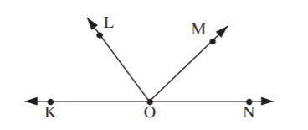
- Which of these is a pair of adjacent angles?
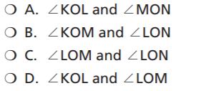

- Given the measure of two of the angles, find the measure of ∠SAP. Simplify your answer.
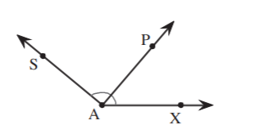
∠SAX = 136
∠PAX = 57

- The measure of ∠PQS is 150°. What is the value of x? Simplify your answer.
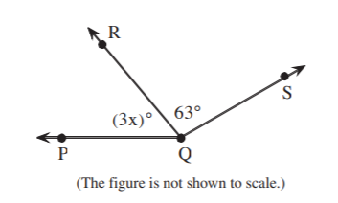

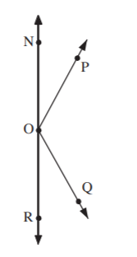
- Which of these is a pair of adjacent angles?
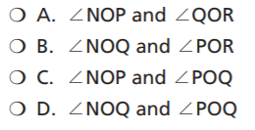

- Find the value of x in the figure.
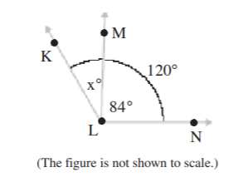

- Which of these is a pair of adjacent angles? Check all that apply.
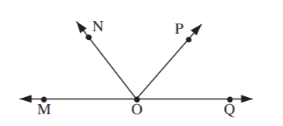
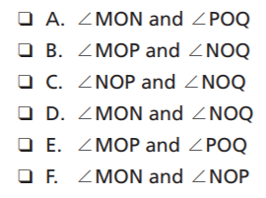

- The measure of ∠TOW is 145°. What is the value of x? Give the measures of the angles.
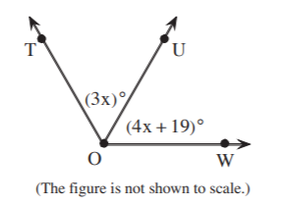

Lesson 10-3 Homework

- Which figure shows an adjacent complement for the given angle?
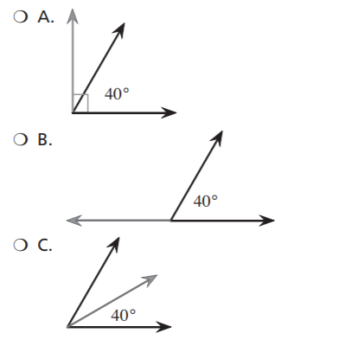

- Find the measure of the complement of an 18° angle.

- ∠1 and ∠2 are complementary angles. The measure of ∠1 is 42°. The measure of ∠2 is 3x°. Find the value of x.
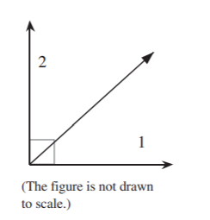

- ∠1 and ∠2 are complementary angles. The measure of ∠1 is 18°. The measure of ∠2 is 12x°. Find the value of x.

- Adjacent angles ∠1 and ∠2 are complementary angles. The measure of ∠1 is 35°. The measure of ∠2 is (8x – 1)°. Find the value of x.
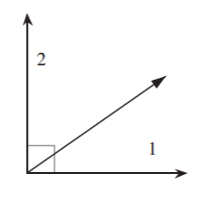

- The measure of ∠1 is 39°. Find the measure of the angle adjacent to ∠1.
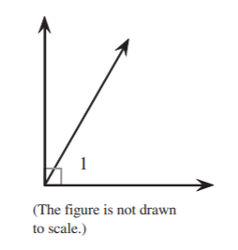

- ∠1 and ∠2 are complementary angles. The measure of ∠1 is 55°. The measure of ∠2 is 5(x + 1)°. Find the value of x.
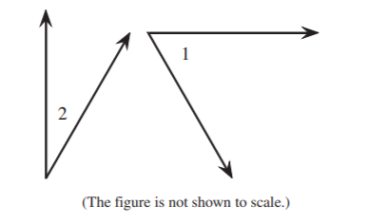

- Which figures represent the adjacent complements? Check all that apply.
